Question 10 [6 Points]
Write a C program demonstrating signal handling.
• Parent process runs indefinitely
• Child process sends SIGTERM after 5 seconds
• Another child sends SIGINT after 10 seconds
• Parent handles each signal differently and exits gracefully

-----
Script:
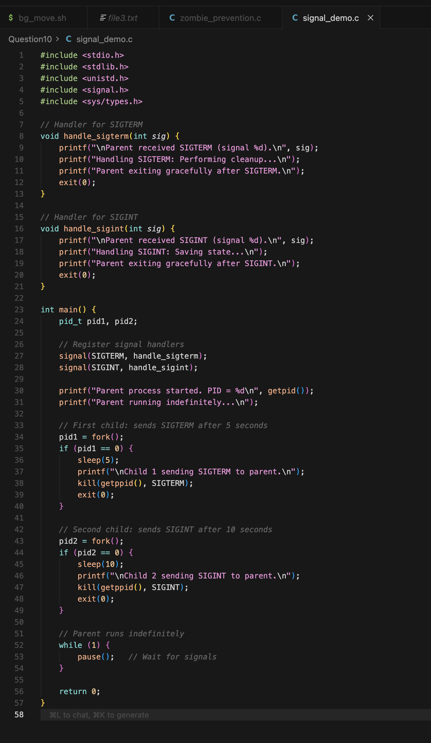

Outcome

